

Assessment Cover Page

Student Full Name: | Andrea Diaz Medrano
Student Number: | 2026627
Module Title: | Strategic Thinking
Assessment Title: | CA 1 – Capstone Project Proposal
Lecturer/Supervisor: | Taufique Ahmed
Assessment Due Date: | 21-09-2026
Date of Submission: | 25-10-2026
Contents
I. Project Title 2
II. Introduction 3
III. Problem Definition 4
IV. Aim and Objectives 4
V. Scope 4
VI. Methodology 4
VII. Data Sources 4
VIII. Expected Deliverables 4
IX. Project Timeline 5
X. Ethical and Legal Considerations 5
XI. References 5

I. Project Title
Predictive Analytics for manufacturing sector greenhouse gas (GHG) emissions, expressed in metric tons of CO₂ equivalent (tCO₂e): Supporting Strategic Sustainability Decision-Making.

II. Introduction
The CO₂ is a gas that forms part of the atmosphere’s natural composition, and its presence is a vital part of Earth’s carbon cycle (EPA, 2026), as shown in Figure 1 below.
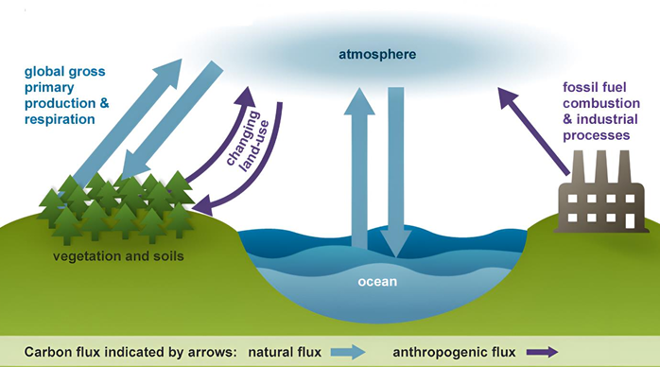
Figure 1. Carbon cycle (Habeeb Fadya A., 2024).
The cycle is usually thought of as four main reservoirs which are the atmosphere, terrestrial biosphere (usually includes freshwater systems), oceans, and sediments (includes fossil fuels) (Environmental Protection Agency (EPA), 2013).
However, human activities, particularly those related to the industrial processes, have disrupted this balance by increasing the concentration of GHG, such as CO₂, water vapor (H₂O), methane (CH₄), nitrous oxide (N₂O), ozone (O₃), and fluorinated gases such as CFCs.
Currently, corporations have a vital role to play in efforts to mitigate global warming as the dominant producers of industrial GHG emissions (John Downie, 2011). These emissions can be quantified using GHG inventories, which may include Scope 1, Scope 2 and Scope 3 emissions (described below in Figure 2) and expressed in tCO₂e.
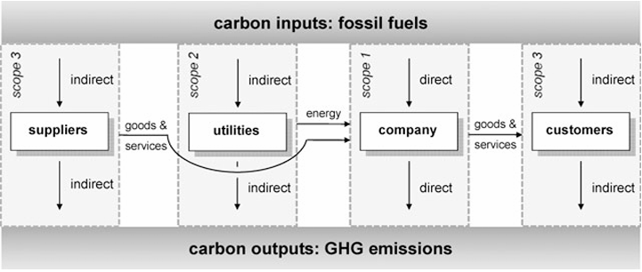
Figura 2. GHG emissiones (Timo, 2008).
Due to the European Commission’s announcement of its intention to reduce net GHG emissions by at least 55% by 2030 compared to 1990 levels (Rainer Kasperzak, 2023) the measures to reduce GHG emissions have become even more relevant. These regulatory frameworks include the Greenhouse Gas Protocol (GHG Protocol) and the European Union’s Corporate Sustainability Reporting Directive (CSRD), to name a few.
However, historical GHG emissions reports alone do not necessarily provide sufficient information to support forward-looking decision-making. Organizations must also understand how their emissions may evolve under different business and operational conditions.
This environmental data can be used to identify patterns and relationships between corporate characteristics and GHG emissions. This presents an opportunity for data analysis and the development of predictive models to estimate future emissions.

III. Problem Definition
The problem addressed by this project is predicting future GHG emissions using historical GHG emissions data from companies in the manufacturing sector, with the results enabling the development of alternatives and measures aimed at managing and reducing the environmental impact of business activities.

IV. Aim and Objectives
Aim
- To determine whether historical GHG emissions data can be used to predict future tCO2e emissions and provide information to support strategic planning for reduction measures in the manufacturing sector.
Objectives:
- To collect, clean and integrate relevant historical corporate and tCO₂e emissions of manufacturing sector.
- To analyse historical patterns and relationships between corporate characteristics, such as revenue or number of employees, and tCO2e emissions generated, for manufacturing sector.

V. Scope
The project will be based on tCO₂e emissions, covering only Scopes 1 and 2; Scope 3 will be entirely excluded.
Only data from companies in the manufacturing sector with at least two years of historical tCO₂e measurements will be considered.

VI. Methodology
Describe how you plan to carry out the project. Explain the proposed data analytics methods, predictive modelling techniques, technologies and tools, and briefly justify your choices.
Include a high-level architectural diagram showing the proposed workflow or system architecture and how the main components are connected. Briefly explain the main components and overall workflow.
The project will use a data analysis and predictive modelling approach to investigate whether historical corporate and environmental data can be used to predict future tCO2e emissions at manufacturing companies. The methodology to be followed will be as follows:
- Data collection and preparation.
The data will be cleaned and prepared to identify missing values, duplicate records or differences in units of measurement. The final selection of variables (such as, revenue or number of employees) will depend on their availability, quality and consistency.
- Exploratory data analysis.
An exploratory data analysis will be conducted using descriptive statistics, visualization and correlation analysis. The main objective will be to identify patterns in emissions and explore the relationships between emissions and company characteristics. This analysis will also allow us to define the mean, median, standard deviation, minimum and maximum values as well as the identification of missing and outlier values.

VII. Data Sources
Identify the dataset(s) or data sources you intend to use. Describe the type and approximate amount of data required, its relevance to the business problem, and evidence of appropriate permission or rights to access and use the data.
We will attempt to obtain information on manufacturing tCO2e emissions from the Mycelium database, cuya Plataforma tiene acceso gratuito al API para usos academicos. La solicitud para el acceso ya fue enviada y esta en espera de aprobaciòn. De aprobarse el acceso se preteden decargar los datos de varibles adicionales a las emisiones de tCO2e como las ventas y numero de emplados para evaluar su influencia sobre las emisiones. De no proporcionarse el acceso al API se obtendran los datos de acceso publico y se trabajaran con ellos.

VIII. Expected Deliverables
Clearly state what you expect to produce by the end of Semester 2, including the expected analytical and predictive modelling outputs and any relevant dashboard, application, system or other project deliverables.

IX. Project Timeline
Provide a high-level project timeline diagram (e.g., a Gantt chart) covering both semesters. Clearly show the main project phases, key activities, milestones and expected completion periods.

X. Ethical and Legal Considerations
Identify relevant ethical, privacy, data protection, security and data-use considerations associated with the project. Explain how these will be appropriately addressed, including permissions for accessing and using the selected data.

Sample Ideas for Capstone Projects:
Predictive Analytics for Customer Churn in E-commerce.
Increasing company sales
Financial Fraud Detection (Anomaly detection)
Personalised pricing.
Event analysis
Sports predictions (games, players, plays)

Remember that these project ideas are just starting points. Ensure that your project proposal outlines a comprehensive and in-depth analysis that will occur over two semesters.

Glosario

